“SMART HOME AUTOMATION”

ABSTRACT.

Revolutionizing the modern world, high-tech appliances have ushered in an era of convenience and automation. With the advent of devices such as TV remotes and other electrical gadgets, our lives have become significantly easier. As our busy lifestyles leave little time for manual management, the concept of home automation has gained traction. This entails using a controller to operate various electronic items in our houses, including fans, LED bulbs, and more. The rapid development of automation has witnessed the emergence of domestic technologies like Apple's Home, Google Home, Amazon Echo, and Zigbee automation, with numerous startups working in this field.While these technologies make our homes smarter, they often come with a hefty price tag. Hence, the aim of this project is to create an efficient and cost-effective home automation system. This system leverages everyday household items like fans and geysers, implementing them into the automation setup. By utilizing a microcontroller and integrating support from programs like IFTTT and Blynk, voice commands received by virtual assistants like Siri or Alexa are translated. When required, the microcontroller controls relays connected to appliances, turning them on or off based on the user's requests to the voice assistants. The NodeMCU (ESP8266) microprocessor is employed in this setup, establishing a connection with the microprocessor using Wi-Fi technology.

CHAPTER NO.

1

2

3

4

5

6

TITLE OF CONTENTS

ABSTARCT
LIST OF FIGURES LIST OF TABLES

INTRODUCTION
1.1 General
1.2 Scope of the Project

LITERATURE SURVEY
SYSTEM STUDY
3.1 Existing system
3.2 Proposed system
REQUIREMENT SPECIFICATION
4.1 Software specification
4.2 Hardware specification

SYSTEM SPECIFICATION
5.1 System Configuration
5.1.1 Hardware System Configuration
5.1.2 Software System Configuration

SYSTEM IMPLEMENTATION

  - Module Overview
  - Module Description

7
CONCLUSION AND FUTURE SCOPE

REFERENCES
APPENDIX A
- Nodemcu code
- Nodemcu datasheet

FIGURE NO | TITLE | PAGE NO
3.1.1 | Node MCU | 10
3.1.2 | Relay switch | 12
3.1.3 | Jumper Wires | 14
3.1.4 | Power supply | 15
3.1.5 | DC motor | 16
3.1.6 | LED Bulb | 17
3.1.7 | Smart plug | 18
3.1.8 | Relay Switch | 18
3.2.2 | Arduino IDE | 22
3.2.3 | Blynk application | 23
3.2.4 | Blynk Architecture | 24
4.2.1 | System design | 31
5.1.1 | Hardware connection | 33
5.1.2 | Before connect the equpiments | 34
5.1.3 | Relay is OFF in system the light also OFF | 34
5.1.4 | Relay is ON in system the light is ON | 35

CHAPTER-1

INTRODUCTION

21st century is the era of convenient, comfortable, secure and economical appliances. Humans have created home automation as a means of achieving their goal in order to make this a reality. Home automation can be defined as a system of hardware, communication, and electronic interfaces that connects common households devices to each other over the net. The world is delighted to have constantly evolving technologies that revolutionized the way one looks at home appliances. The main goals of technology are to make things easier and more efficient. Iot devices has been given a lot of prominence in today's popular culture. Because automation requires less work and is more effective, we may successfully operate the appliances in many different locations by utilizing IOT. There truly isn't any support developing for individuals who are physically unable to profit from technology, despite the fact that it continues to improve in our daily lives. However, introducing technologies that are supported by voice-activated home automation is one method to become technologically inclusive. Once we actually build the speech-enabled home automation systems, voice control of the appliances will be possible. Customers' speech will therefore be supplied into the microphone as an input, and the microphone will then pick up the customers' voice and send it to the recognition module. If there are any interruptions, the system will search for nearby words and, if it finds the order (ON or OFF ), will carry out the pre- programmed operation. The project is set up to create a low-cost ecosystem using only a relay board, IFTTT, blynk, and nodeMCU as its primary components.

1.2 SCOPE OF THE PROJECT

The scope of the project includes designing and implementing an efficient and pocket-friendly home automation system using everyday household items like fans and geysers. The project aims to provide a convenient and automated solution for controlling these appliances through voice commands received by virtual assistants like Siri or Alexa.

The system will utilize a microcontroller, specifically the NodeMCU (ESP8266), as the central processing unit. The microcontroller will be responsible for receiving and translating voice commands through programs like IFTTT and Blynk. Wireless connectivity, such as Wi-Fi, will be established between the microcontroller and the various appliances.

The project will involve integrating relays with the microcontroller to control the power supply of the connected devices. These relays will be switched on or off based on the user's voice commands, allowing for remote operation of the appliances. The system will ensure that the appliances respond to the user's requests in real-time.

To ensure cost-effectiveness, the project will focus on utilizing readily available components and minimizing the overall investment required. The implementation will also take into consideration the ease of installation and usability, ensuring that users can easily set up and interact with the home automation system.

The scope may also involve exploring additional functionalities beyond controlling fans and geysers, such as integrating LED bulbs or other electronic devices into the automation system.Overall, the project aims to create a practical, affordable, and user-friendly home automation solution that enhances convenience and efficiency for users in managing their household appliances.

CHAPTER-2

CHAPTER 2
LITERATURE SURVEY

Literature survey on IOT and Smart grid

Anjum Ara, Shivkumar Jawaligi
Paper got published in 2019
With a constant development in technology, voice command systems such as Amazon Alexa and Apple’s Siri is becoming a more natural part of standard living. We saw many home automation technologies introduced over these years from Zigbee automation to Amazon Echo, Google Home and Home from Apple. It has become a craze these days. The expense of these gadgets is more with an extra expense of the devices to be associated with. So, overall we can see here that to make our home smart we have to contribute a considerable amount, for a basic setup. Imagine a scenario where we can automate our home with low cost and can control up to 9 appliances utilizing Google Assistant. Indeed, this projet portrays the usage of such a framework.

iHAS: An Intelligent Home Automation Based System for Smart City

Shaik Mulla Shabber
Paper got published in 2021
Abstract: Nowadays, people are looking for methods to improve their lifestyles by utilising the latest technologies accessible. Various home automation system have grown in popularity over the last decade, and it improves comfort and quality of life. The proposed work explores an intelligent home automation system (iHAS) that allows the user to monitor electrical appliances of the home from everywhere in the world. This system can be used to describe how all home appliances function together and control them using the laptop, Android smartphone, or tablet with internet access. The home automation system can be installed in existing home environments without requiring any infrastructure changes. This paper explored the design and implementation of an individual control home automation device utilising Wi-Fi enabled micro-controller unit. The user can have complete control over the home appliances and devices from anywhere using only an Android app and an internet connection.

“Automation of Smart Home using Smart Phone via Google Assistant”

by Rajesh Rishi and Pinki

Paper got published in 2021
Abstract: The main objective of this system is to automate every connected device by use the interface which are the AI and the application program designed purposely for the technology. It is as easy as it only requires to press a button or give a command through the arbitrary system. With technology advancing in this era houses, offices, workplaces or any other place where there is a roof, they are becoming smarter and smarter. Present day homes are gingerly transitioning from traditional control to a more consolidated directed arrangement, involving wireless data transfer through mobile device, smart phones which has specifically in-built interface to interact with it. Current, ordinary and standard home switches established in contrasting parts of the house contribute to its difficulty that adds to the user using it to go close to them for it to operate. The physically impair persons who are put at an advantage due to their disorder sees it strenuous to perform these measures. Secluded administered home automation system technology come up with a most ingenious remedy with intellect phones. This is achieved through effective data and particulars distribution to the controller which fundamentally and indubitably present the adequate results to the components with which the user wants to have interchange of information with. This interplay with the particulars such as the strings sent over a networking protocol achieve the appropriate outcome with when the process will pull of the requisite consequence and effect the person using it desires.

“Enhanced Smart Home Automation System based on Internet of Things”

By Mummaka Sai Srinath ,Manepalli Nanda Kishore ,M.D. Anto Praveena
Paper got publish in 2018
Abstract : This is an interactive home automation system that is unique in its own way that it is unlike any other existing home automation systems that have been made previously. Most of the existing systems that are available in the market use a Raspberry Pi or Arduino chipset that are programmed to control a set of devices inside a house, which are given instructions using a mobile application or a web-based UI. Unlike them, this device focuses on controlling the devices using voice recognition and artificial intelligence, while being interactive as well. This is achieved by utilizing the open sourced API of Google Assistant by Google Inc
[5] “Smart Home Systems: Overview and Comparative Analysis” By Mr. Kalyan Chenumalla, Mr. Srikanth Gottam, Mr. Prashanth Kusuma, Ms. P. Bhavya Shri
Paper got published in 2019
Abstract: The idea behind Google assistant-controlled Home automation is to control home devices with voice. On the market there are many devices available to do that, but making our own is awesome. In this project, the Google assistant requires voice commands. Adafruit account which is a cloud based free IoT web server used to create virtual switches, is linking to IFTTT website abbreviated as “If This Than That” which is used to create if else conditional statements. The voice commands for Google assistant have been added through IFTTT website. In this home automation, as the user gives commands to the Google assistant, Home appliances like Bulb, Fan and Motor etc., can be controlled accordingly. The commands given through the Google assistant are decoded and then sent to the microcontroller, the microcontroller in turn control the relays connected to it. The device connected to the respective relay can be turned On or OFF as per the users request to the Google Assistant. The microcontroller used is NodeMCU (ESP8266) and the communication between the microcontroller and the application is established via Wi-Fi (Internet).

CHAPTER-3

CHAPTER 3

SYSTEM STUDY

3.1 EXISTING SYSTEM

The existing home automation system incorporates various devices and techniques for operating appliances in a home. These include the use of PCs, laptops, wireless switches, and smartphones as control interfaces. Additionally, several techniques have been adopted to implement home automation, such as automation, Zigbee, Bluetooth, ARM9, SMS, and Android ADK.The system allows users to control and manage their appliances remotely using different control interfaces. For instance, a PC or laptop can be utilized to access a graphical user interface (GUI) or a web-based interface that enables users to interact with the home automation system. Through these interfaces, users can send commands to the system to turn on/off appliances, adjust settings, or schedule operations. Wireless switches are another component of the system, providing a physical means of controlling appliances. These switches can be strategically placed around the home, allowing users to turn appliances on/off with the press of a button. Smartphones play a crucial role in the existing system, serving as portable control devices.
.
Disadvantages of the existing home automation system:
1. High cost and initial investment.
2. Complexity in setup and configuration.
3. Compatibility issues between different devices and protocols.
4. Reliability and stability concerns.
5. Security risks and potential vulnerabilities.
6. Dependency on technology and infrastructure.
7. Learning curve for users unfamiliar with technology.

3.2 Proposed System:
The proposed system aims to enhance the existing home automation setup by integrating a Wi-Fi module with various sensors for wireless data transmission. The system utilizes the Blynk application and the Wi-Fi module to receive sensor data and provides monitoring capabilities through the Blynk application. Additionally, the Blynk application is used to implement an automatic switch between two sources.In the proposed system, the Wi-Fi module is connected to different sensors, such as temperature sensors, motion sensors, or humidity sensors, enabling wireless transmission of sensor data to the central control unit. This allows for real-time monitoring and analysis of environmental conditions within the home.The Blynk application serves as the user interface, providing a user-friendly dashboard to monitor the data collected by the sensors. Through the Blynk application, users can access and visualize the sensor data, enabling them to make informed decisions or take necessary actions based on the collected information.Furthermore, the Blynk application in the proposed system incorporates an automatic switching feature between two sources. This functionality can be utilized to switch between power sources, such as electricity and backup generators, or between different internet service providers (ISPs) for uninterrupted connectivity. The Blynk application automates the process based on predefined criteria, ensuring a seamless transition between the sources without requiring manual intervention.
Advantages of the proposed system:
1. Enhanced wireless connectivity for seamless data transmission.
2. Real-time monitoring of sensor data through a user-friendly interface.
3. Improved automation with automatic source switching.
4. Increased control and efficiency in managing the home automation system.

CHAPTER 4

4)HARDWARE AND SOFTWARE USED

4.1)HARDWARE REQUIREMENTS
Node MCU Relay module Power supply Bulb
Jumper wires

NODE MCU
NodeMCU is an open-source Lua based firmware and development board specially targeted for IoT based Applications.
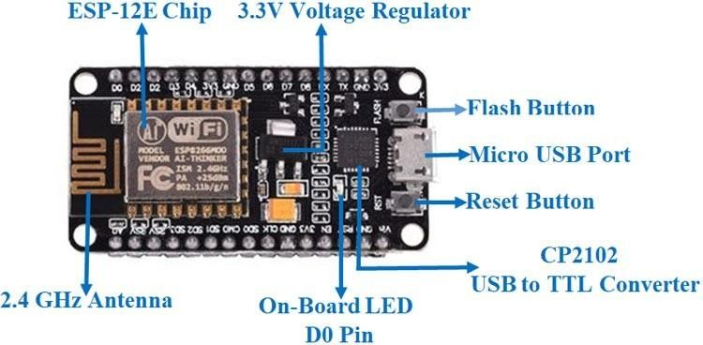
It includes firmware that runs on the ESP8266 Wi-Fi SoC from Espressif Systems, and hardware which is based on the ESP-12 module. Esp8266 is a low cost WI-FI chip with full TCP/IP stack and microcontroller capability produced shanghai-based chinese manufacturer.

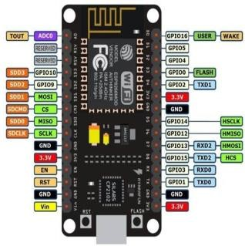
FIG 4.1.1 Nodemcu Pin Diagram

FEATURES OF NODE MCU(ESP8266):
- Open-source
- Interactive
- Programmable
- Low cost
- Simple
- Smart
- WI-FI enabled
- USB-TTL Included
- Plug &Play

SPECIFICATIONS OF NODE MCU(ESP8266):
    - Developer : ESP8266 opensource community
    - Type : Single board microcontroller
    - Operating System : XTOS
    - CPU : ESP826
    - Memory : 128kBytes
    - Storage : 4MBytes
    - Power By : USB
    - Power Voltage : 3v,5v(used with 3.3v Regulator inbuilt onboard using
pin)
    - IDE USED : Arduino IDE
    - GPIO 10

ADVANTAGES OF NODE MCU:
- Low energy consumption
- Integrated support for WIFI network
- Reduced size of the board
- Low cost

RELAY MODULE:
A relay is an electrical device which is generally used to control high voltages using very low voltage as an input.
This consists of a coil wrapped around a pole and a two small metal flaps(nodes) that are used to close the circuit. One of the node is fixed and other is movable.
Whenever an electricity is passed through the coil, it creates a magnetic field and attracts the moving node towards the static node and the circuit gets completed.
so, just by applying small voltage to power up the coil we can actually complete the circuit for the high voltage to travel.
Also as the static node is not physically connected to the coil there is very less chance that the microcontroller powering the coil gets damaged if something goes wrong.

2 channel Relay features:
Number of Relays 2
Control signal : TTL Level
Rated load : 7A/240VAC,10A/125VAC,10A/28VDC
Contact action time : 10ms/5ms
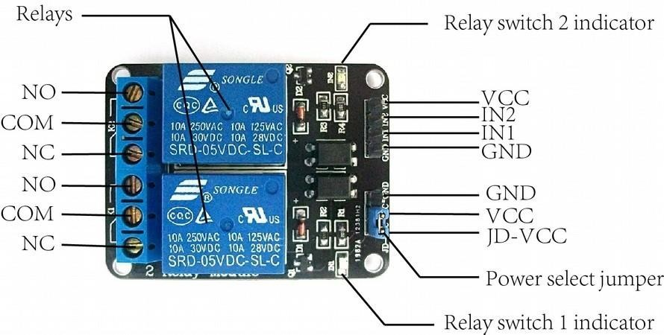
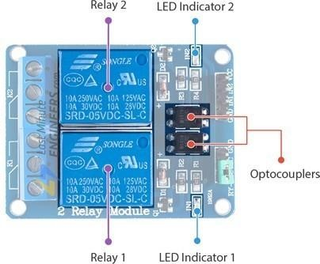
Fig 4.1.2

PIN DESCRIPTION:
Pin Name Description
- Vcc : Power(5V DC)
- GND : Gnd
- in1 : signal pin, connected with Aruino and control
Relay1
- in2 : singal pin,connected with Arduino and control
Relay2
- COM : Common pin,which usually directly connect with the Gnd unless you want to change the TTLmodel default the HIGH level activate)
- NO : Normally open connection
- NC : Normally close connection

Advantages:
- Relays are a better choice for switching large currents(>5A).
- Relays can high voltages, transistorscannot.
- Relays can switch many contacts at once.
- Relays can switch AC and DC, transistors can only switch the DC.

OVERVIEW:
We can control high voltage electronic devices using relays. A Relay is actually a switch which is electrically operated by an electromagnet.
The electromagnet is activated with a low voltage,for example 5 volts from a microcontroller and it pulls a contact to make or break a high voltage circuit.

LED BULB:

An LED bulb produces light by passing the electric current through a semiconducting material—the diode—which then emits photons (light) through the principle of electroluminescence. Don't let that big word scare you! It essentially means that a material (in this case, the diode) casts light when power is applied to it.
An LED light bulb is a solid-state lighting (SSL) device that fits in standard screw-in connections but uses LEDs (light-emitting diodes) to produce light. LED light bulbs are a more environmentally-friendly alternative to incandescent bulbs.
Visible LEDs are used in many electronic devices as indicator lamps, in automobiles as rear- window and brake lights, and on billboards and signs as alphanumeric displays or even full- colour posters.


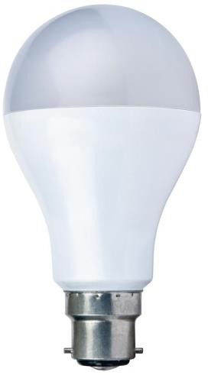
Fig 4.1.6

RELAY SWITCH

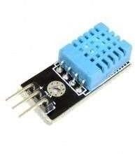


Fig 4.1.8

Relays are switches that open and close circuits electromechanically or electronically. Relays control one electrical circuit by opening and closing contacts in another circuit. When a relay contact is Normally Closed (NC), there is a closed contact when the relay is not energized.

WORKING PRINCIPLE

Relay works on the principle of electromagnetic induction. When the electromagnet is applied with some current it induces a magnetic field around it. A switch is used to apply DC current to the load. In the relay Copper coil and the iron core acts as electromagnet.

5.1SOFTWARE REQUIREMENTS

Arduino ide Blynk application Portronics

Applications:

    - To provide security from threats.
    - It is an all in one system hence no need to carry multiple devices.
    - GPS tracking track the user lively once the system is triggered.
    - When the battery is low it automatically send the current location to the pre-
    - registered numbers.
    - Since this system captures the image of the culprit it helps in future investigation intracking the culprit.

5.1.1ARDUINO IDE


Fig 5.2.2: Arduino IDE

The Arduino Integrated Development Environment (IDE) is a cross-platform application (for Windows, macOS, Linux) that is written in functions from C and C++. It is used to write and upload programs to Arduino compatible boards, but also, with the help of 3rd party cores, other vendor development boards.

Features:
- Writing Sketches. File. Edit. Sketch. Tools. Help
- Sketchbooks
- Tabs, Multiple files and compilation
- Uploading
- Libraries
- Third party hardware
- Serial monitor
- Preferences

5.1.2BLYNK APPLICATION

Fig 5.2.3: Blynk Application

Blynk is a new platform that allows you to quickly build interfaces for controlling and monitoring your hardware projects from your iOS and Android device. After downloading the Blynk app, you can create a project dashboard and arrange buttons, sliders, graphs, and other widgets onto the screen.

FEATURES:
- Version: 2.27.17
- Available on Android and IOS

SETTING UP BLYNK APPLICATION
- Install Blynk application and create a new blynk account
- Create a new project after successfully logging in
- Choose your hardware
- Enter the Authentication token received after logging in inside your program

- Add the widgets required for your project

Blynk works over the Internet- So the one and only requirement is that your hardware can talk to the Internet.

No matter what type of connection you choose - Ethernet, Wi-Fi or maybe this newESP32 everyone is talking about – Blynk libraries and example sketches will get you online, connect to Blynk Server and pair up with your smartphone.
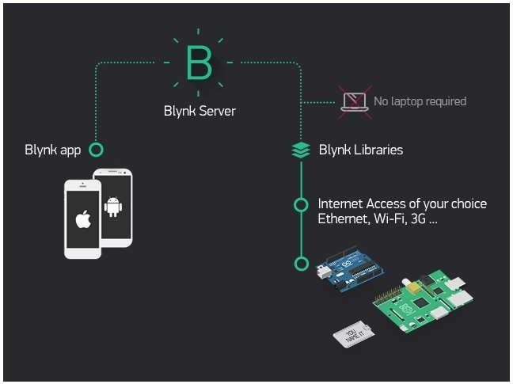
Blynk architecture

Currently, Blynk libraries work with:

- USB
- Ethernet shield
- WiFi shield
- Arduino with Ethernet
- Arduino YÚN (testing in progress)
- ESP32
- Raspberry Pi (Blynk will communicate with Pi's GPIOs)
- more Arduino compatible shields and boards (this list will be updated as we test the compatibility)

It's not that easy to take Arduino out of your home network, so we've built a Blynk server.It handles all the authentication and communication, and also keeps an eye on your board while the smartphone is offline. Blynk server runs on Java and is open-source. You will be able to run it locally if you really need to. Messaging between mobile apps , Blynk Server and Arduino is based on a simple, lightweight and fast binary protocol over TCP/IP sockets.

CREATING A PROJECT IN BLYNK APP

After downloading the app, create an account and log in. Welcome to Blynk!
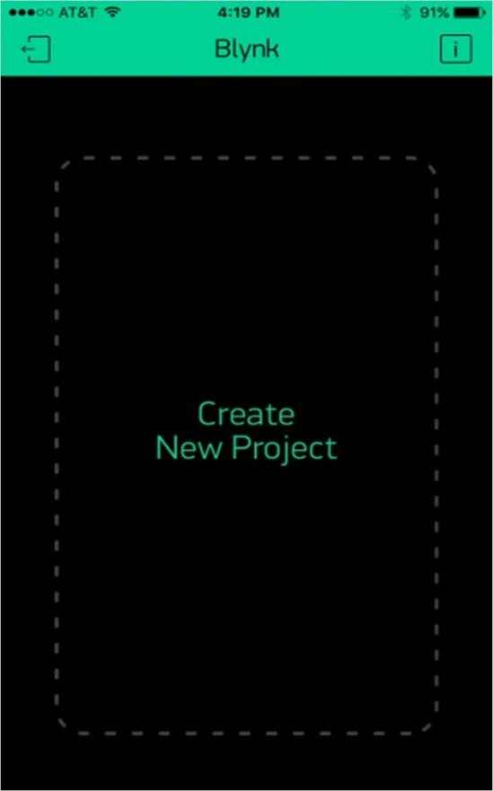

You’ll also need to install the Blynk Arduino Library, which helps generate the firmware running on your ESP32. Download the latest release from Blynk’s GitHub repo, and follow along with the directions there to install the required libraries.

Create a Blynk Project

Next, click the “Create New Project” in the app to create a new Blynk app. Give it anyname you please, just make sure the “Hardware Model” is set to ESP32.

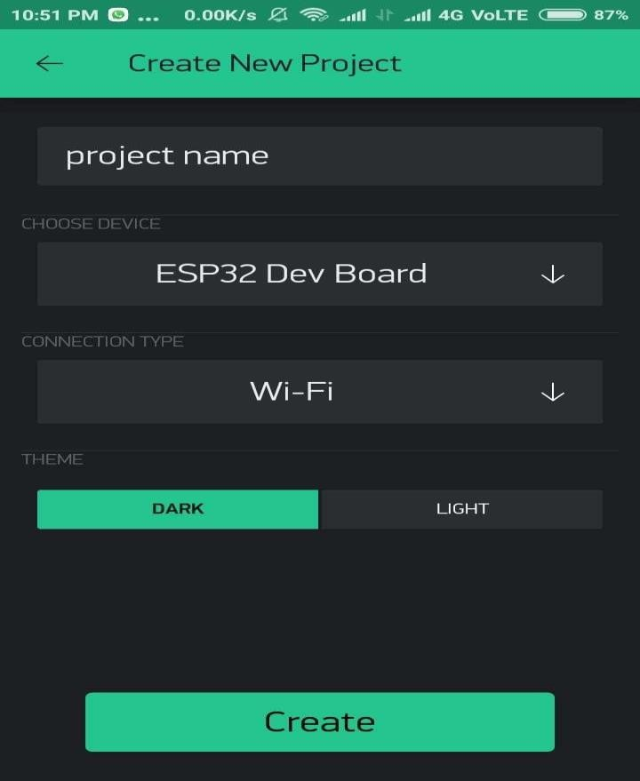

The Auth Token is very important – you’ll need to stick it into your ESP32’s firmware. For now, copy it down or use the “E-mail” button to send it to yourself.

Add Widgets to the Project

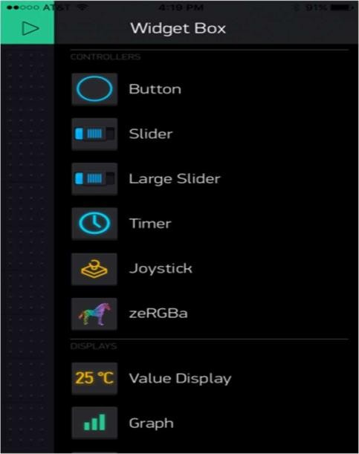
Then you’ll be presented with a blank new project. To open the widget box, click in the project window to open.

Add a Button, then click on it to change its settings. Buttons can toggle outputs on the ESP32. Set the button’s output to gp5, which is tied to an LED on the Thing Dev Board. You may also want to change the action to “Switch.”
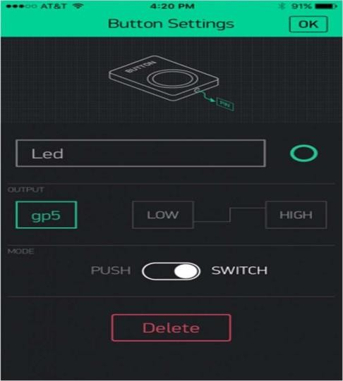

Upload the Blynk Firmware

Now that your Blynk project is set up, open Arduino and navigate to the ESP32_Standalone
example in the File > Examples > Blynk > BoardsAndShields menu.

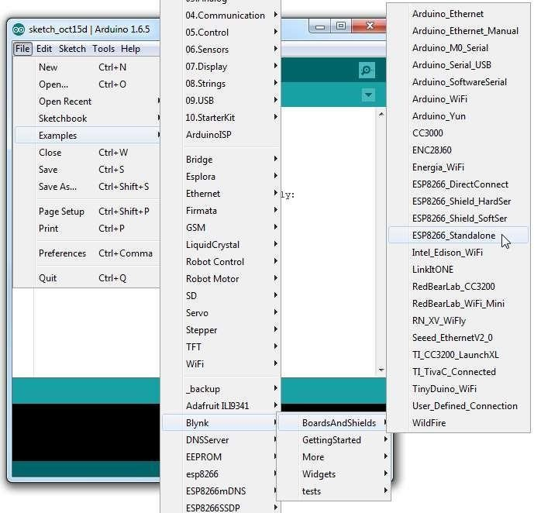

Before uploading, make sure to paste your authoriazation token into the auth[] variable. Also make sure to load your WiFi network settings into the Blynk.begin(auth, "ssid", "pass") function.

Then upload!

Run the Project

After the app has uploaded, open the serial monitor, setting the baud rate to 9600. Wait for the “Ready (ping: xms).” message.

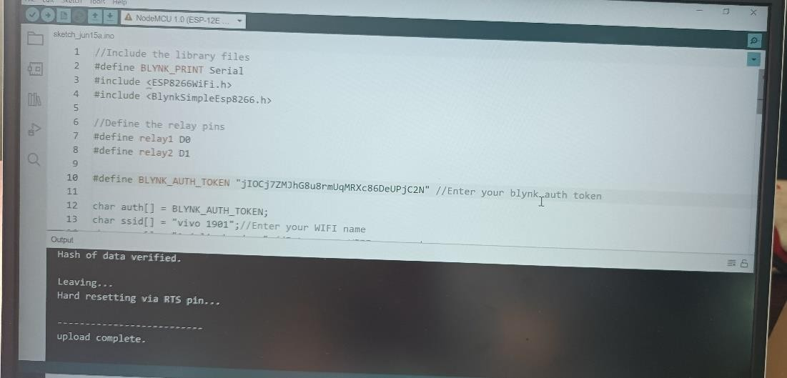

Then click the “Run” button in the top right corner of the Blynk app. Press the button and watch the LED!
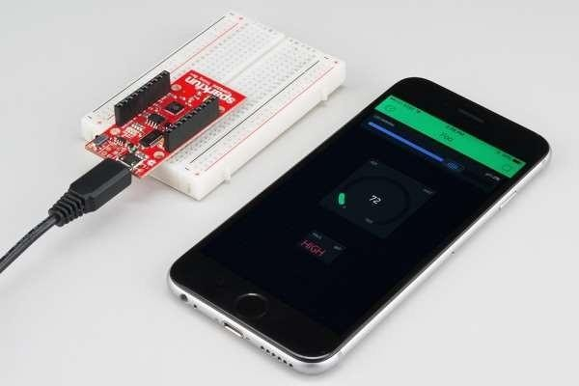

Then add more widgets to the project. They should immediately work on the ESP32 without uploading any new firmware.

CHAPTER-5

Chapter 4: METHODOLOGY

BLOCK DIAGRAM
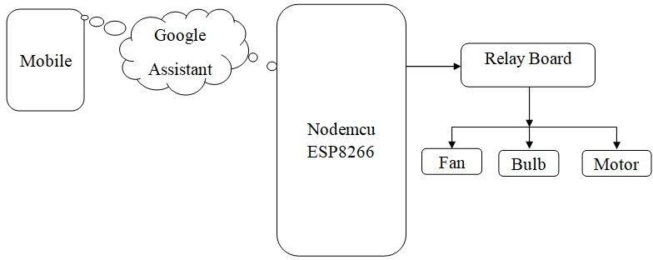

Fig 4.1.1: Block diagram of proposed model

By using mobile we can give commands to Google assistant ,when wesay a voice command like “ok google turn on the light” to the Google Assistant, Google Assistant sends this foreign command to IFTTT. IFTTT interprets this command and sends an On or Off signal to the Blynk app via the Blynk Server. Blynk will then send this signal to theNodeMCU and then to our electrical appliances.

SYSTEM DESIGN
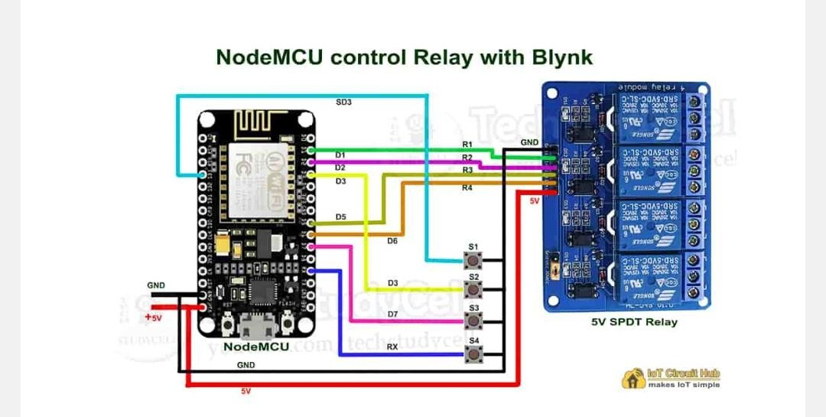
Fig 4.2.1

- Input Block: The input block comprises of 5-volt DC adapter that provide power to the processing unit.
- Processing Unit: Node MCU ESP8266 and Arduino UNO is the main drain of the system.
- Output Block: The output block comprises of a relay module which triggered according to the input (Google voice assistant) of the input block.
- In this home automation, as the user gives commands to the google assistant, home appliances like bulb, fan and motor etc, can be controlled accordingly.
- The commands given through the google assistant are decoded and then sent to the node mcu, the node mcu in turn control the relays connected to it.

CHAPTER-5

CHAPTER 5: RESULTS AND DISCUSSION

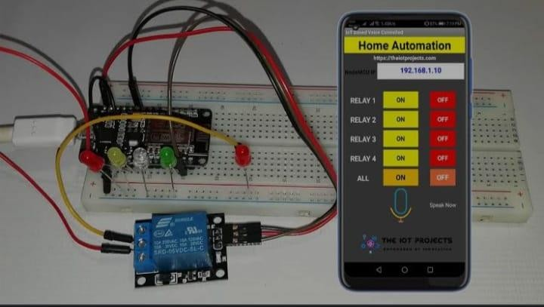
Fig 5.1.1
Smartphones can be used to access Google Assistant. For example, if a person says on their phone, "OK Google, turn onthe fan," it starts the process because Google Assistant will begin sending the received command to IFTTT. IFTTT will interpret it and send the command, which could be an ON or OFF signal, to the blynk app via its server. which blynk willthen relay to NodeMCU, which will decode the signal and send it to our electronic devices By the way, it's not always a simple as it appears; for example, the connection between our voice and fan can fail. As a result, if the fan does not turnon, then a few precautions must be taken to ensure that it starts.

The fan should be turned on or off whenever the consumer toggles the switches on the Adafruit IO centre console. If thefan is not turned on, there may be a problem connecting to the server, it may not be subscribing to the field, or it may bechecking the wrong string values. Examine the ESP8266 device's digital indicator output to figure out what's wrong withit.

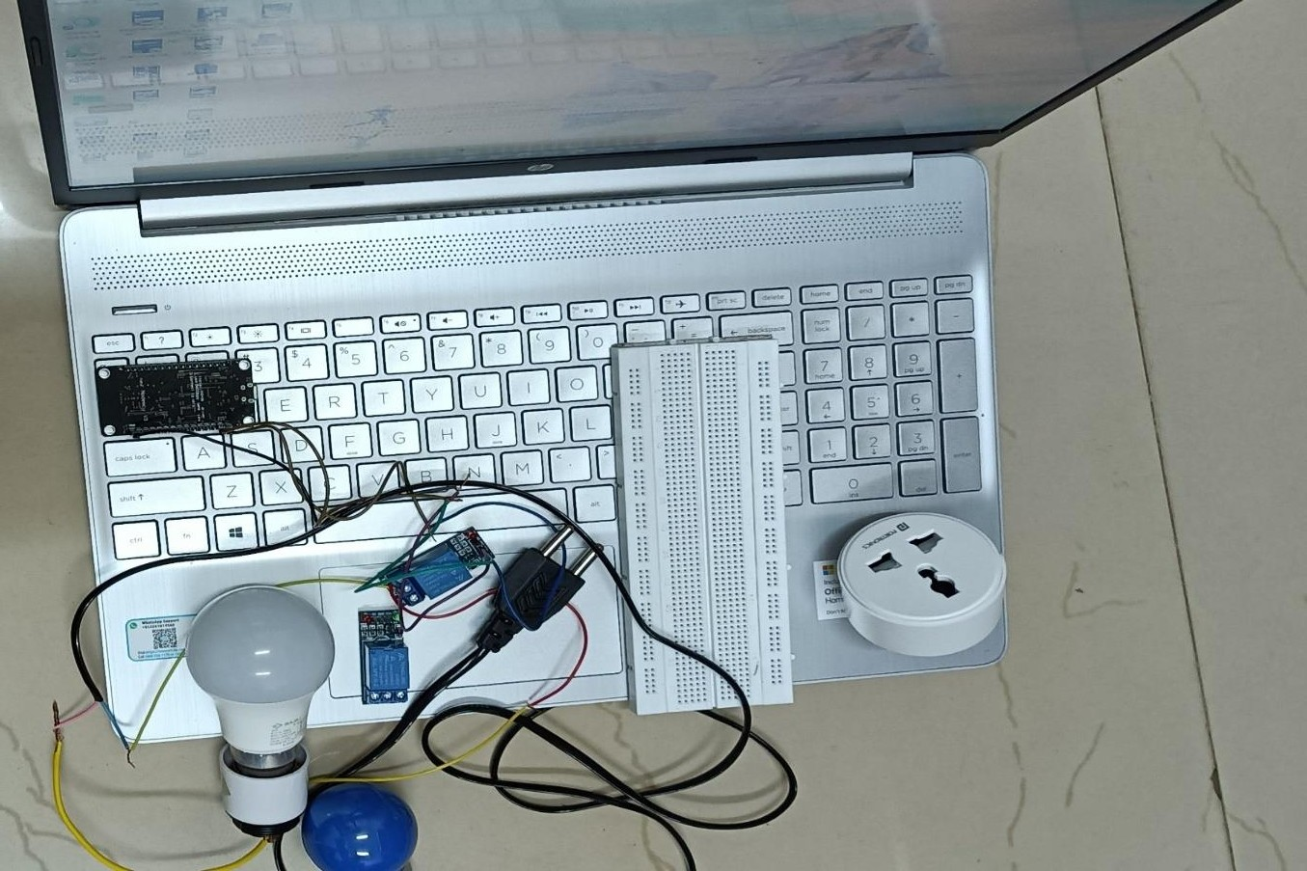

5.1.2Before connect the equipment

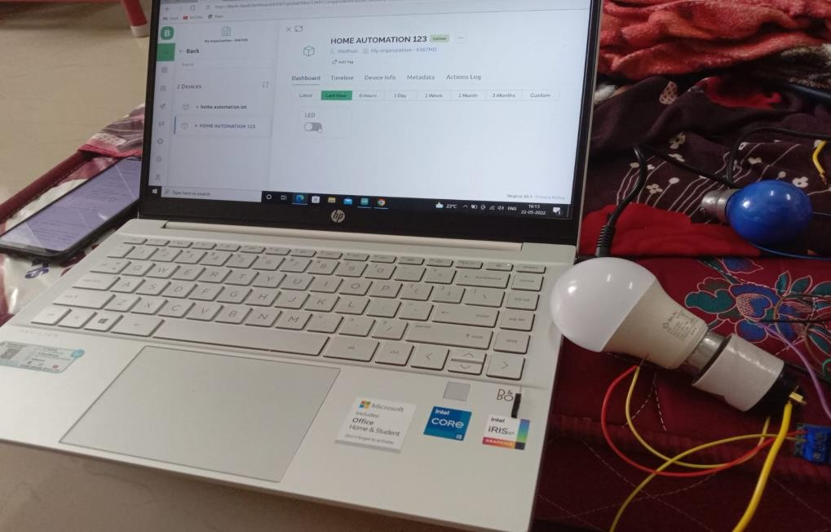

5.1.3 Relay is off in system the light is also off

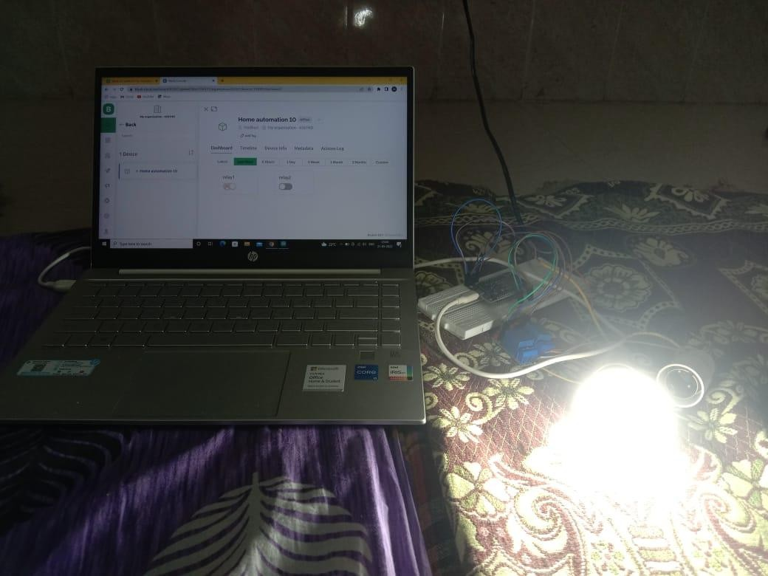

5.1.4 Relay is on in the system light is on

CHAPTER 6

Chapter 6: APPLICATIONS AND ADVANTAGES

Applications:
    - We can turn on or off appliances using Phone or tablet.

    - The project can be further expanded to a smart home automation system by including some sensors like lights sensors, temperature sensor, Safety sensors etc. and automatically monitor(room temperature), door lock status etc, and transmit the information to our phone.

    - Lightning control system.

    - Security system.

Advantages:

    - Reduce human efforts.
    - Managing all of your home devices from one place. The convenience factor here is enormous
    - Increased energy efficiency
    - It is available at low cost
    - Voice control home function

CHAPTER 7

Chapter 7: CONCLUSION AND FUTURE SCOPE

CONCLUSION
In this project, voice commands are given to the Google assistant. The voice commands for Google assistant have been added through IFTTT website and the Blynk app is also linked to it. In this home automation, user have given commands to the Google assistant.LED’s are controlledaccording to the given commands or( Home appliances like Bulb,Fan and Motor etc., are controlled according to the given commands. The commands given through the Google assistant are decoded and then sentto the microcontroller and it control the relays. The device connected tothe respective relay turned On or OFF as per the users request to the Google Assistant.The microcontroller used is NodeMCU (ESP8266) andthe communication between the microcontroller and the application is established via Wi-Fi (Internet).)

This project is about wireless home automation using Android mobile helps us to implement such a fantastic system in our home at a very reasonable price using cost-effective devices. Thus, it overcomes many problems like costs, inflexibility, security etc. In addition, will provide greater advantages like it decrease our energycosts, it improves home security. In addition, it is very convenient to use and will improve the comfort of our home. The project has proposed the idea of smart homes that can support a lot of home automation systems. C# programming language and Node microcontroller have been used to connect the sensors circuit to the home.
Also, in home and building automation systems, the use of wireless technologies gives several advantages which cannot be achieved byusing a wired network.
- Reduced installation costs.
- Easy deployment, installation, and coverage.
- System scalability and easy extension.
- Integration of mobile devices.

FUTURE SCOPE

There are a variety of enhancements that could be made to this systemto achieve greater accuracy in sensing and detection.
- There are a lot of other sensors that can be used to increase the security and control of the home like pressure sensor that can be put outside the home to detect that someone will enter the home.
- Future scope for the home automation systems involves making homes even smarter.
- Homes can be interfaced with sensors including motion sensors, light sensors and temperature sensors and provide automated toggling ofdevices based on conditions.

REFERENCES

REFERENCES
[1]. Mummaka sai Srinath, Manepalli Nanda Kishore, ‘Interactive home automation system with google assistant’, International Journal of pure and applied mathematics,Year:2018,Volume 119, No.12.

[2]. Madhuri Das, ‘Home Automation Using ESP8266’,Transaction on machine design,Year:2018,Volume 06,No.02.

[3]. Anjum Ara, Shivkumar Jawaligi,‘NodeMCU(ESP8266) control home automation using google assistant’, International research journal of engineering and technology,Year:2019,Volume:06,Issue:07.

[4]. Mr. Kalyan Chenumalla, Mr. Srikanth Gottam, Ms.p.Bhavya Shri, ‘Google Assistant Controlled Home Automation’, IEEE VEC SB,Year:2019.

[5].RajeshRishi, PinikDoloi, ‘Home automation using google assistant’, International journal of innovative research in electrical, electronics, instrumentation and control engineering,Year:2021,Volume:09,issue:06.

[6] Hittu Garg, Mayank Dave ,‘Securing IoT Devices and SecurelyConnecting the Dots Using REST API and
Middleware ’ 2019 4th International Conference on Internet of Things: Smart Innovation and Usages (IoT-SIU)
Year :2019
[7] C. Wang, G. Yang, G. Papanastasiou, H. Zhang, J. Rodrigues, and V. Albuquerque,
‘‘Industrial cyber-physical systems-based cloud IoT edge for federated heterogeneous
distillation,’’ IEEE Trans. Ind. Informat., early access, Jul. 7, 2020, doi:
10.1109/TII.2020.3007407.
38
[8] A. M. Elmisery, M. Sertovic, and B. B. Gupta, ‘‘Cognitive privacy middle
ware for deep learning mashup in environmental IoT,’’ IEEE Access, vol. 6, pp. 8029–
8041, 2018.
[9] F. Montori, L. Bedogni, and L. Bononi, ‘‘A collaborative Internet of Things
architecture for smart cities and environmental monitoring,’’ IEEE Internet Things J.,
vol. 5, no. 2, pp. 592–605, Apr. 2018.
[10] B. Keswani, A. G. Mohapatra, A. Mohanty, A. Khanna, J. J. P. C. Rodrigues, D.
Gupta, and V. H. C. de Albuquerque, ‘‘Adapting weather conditions based IoT
enabled smart irrigation technique in precision agriculture mechanisms,’’ Neural
Comput. Appl., vol. 31, no. S1, pp. 277–292, Sep. 2018.
[11] L.-M. Ang, K. P. Seng, A. M. Zungeru, and G. K. Ijemaru, ‘‘Big sensor data
systems for smart cities,’’ IEEE Internet Things J., vol. 4, no. 5, pp. 1259–1271, Oct.
2017.
[12] J. Santos, T. Vanhove, M. Sebrechts, T. Dupont, W. Kerckhove, B. Braem, G. V.
Seghbroeck, T. Wauters, P. Leroux, S. Latre, B. Volckaert, and F. D. Turck, ‘‘City of
things: Enabling resource provisioning in smart cities,’’ IEEE Commun. Mag., vol. 56,
no. 7, pp. 177–183, Jul. 2018.
[13] K. Pardini, J. J. P. C. Rodrigues, O. Diallo, A. K. Das, V. H. C. de Albuquerque,
and S. A. Kozlov, ‘‘A smart waste management solution geared towards citizens,’’
Sensors, vol. 20, no. 8, p. 2380, Apr. 2020.

APPENDIX

Data sheet of NODE MCU ESP8266

The NodeMCU ESP8266 development board comes with the ESP-12E module containing the ESP8266 chip having Tensilica Xtensa 32-bit LX106 RISC microprocessor. This microprocessor supports RTOS and operates at 80MHz to 160 MHz adjustable clock frequency. NodeMCU has 128 KB RAM and 4MB of Flash memory to store data and programs. Its high processing power with in-built Wi-Fi / Bluetooth and Deep Sleep Operating features make it ideal for IoT projects.
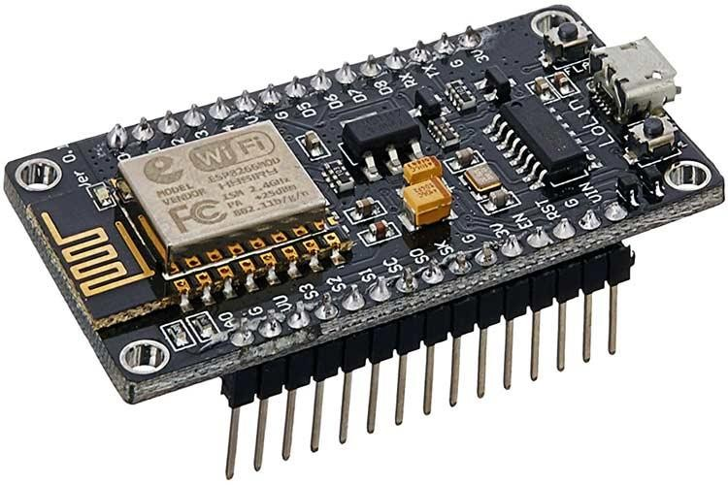
NodeMCU can be powered using a Micro USB jack and VIN pin (External Supply Pin). It supports UART, SPI, and I2C interface.

The NodeMCU Development Board can be easily programmed with Arduino IDE since it is easy to use.Programming NodeMCU with the Arduino IDE will hardly take 5-10 minutes. All you need is the Arduino IDE, a USB cable and the NodeMCU board itself. You can check this Getting Started Tutorial for NodeMCU to prepare your Arduino IDE for NodeMCU
Once Arduino IDE is installed on the computer, connect the board with the computer using the USB cable. Now open the Arduino IDE and choose the correct board by selecting Tools>Boards>NodeMCU1.0 (ESP-12E Module), and choose the correct Port by selecting Tools>Port. To get it started with the NodeMCU board and blink the built-in LED, load the example code by selecting Files>Examples>Basics>Blink. Once the example code is loaded into your

IDE, click on the ‘upload’ button given on the top bar. Once the upload is finished, you should see the built-in LED of the board blinking

SPECIFICATIONS:
Pin Category | Name | Description
Power | Micro-USB, 3.3V, GND, Vin | Micro-USB: NodeMCU can be powered through the USB port  3.3V: Regulated 3.3V can be supplied to this pin to power the board  GND: Ground pins  Vin: External Power Supply
Control Pins | EN, RST | The pin and the button resets the microcontroller
Analog Pin | A0 | Used to measure analog voltage in the range of 0-3.3V
GPIO Pins | GPIO1 to GPIO16 | NodeMCU has 16 general purpose input-output pins on its board
SPI Pins | SD1, CMD, SD0, CLK | NodeMCU has four pins available for SPI communication.
UART Pins | TXD0, RXD0, TXD2, RXD2 | NodeMCU has two UART interfaces, UART0 (RXD0 & TXD0) and UA (RXD1 & TXD1). UART1 is used to upload the firmware/program.

I2C Pins |  | NodeMCU has I2C functionality support but due to the internal functionalit these pins, you have to find which pin is I2C.

PINOUT CONFIGURATION:
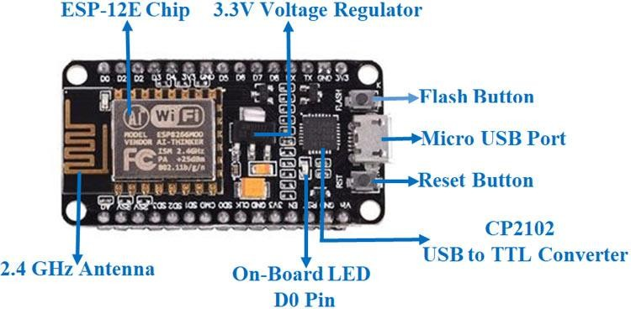

Fig: ESP-8266 GPIO PIN

PIN DEFINITION:

Pin | Name | Type | Functio n
1 | VDDA | P | Analog Power 3.0 ~3.6V
2 | LNA | I/O | RF Antenna Interface. Chip Output Impedance=50Ω  No matching required but we recommend that the π-typematching network is retained.
3 | VDD3P3 | P | Amplifier Power 3.0~3.6V
4 | VDD3P3 | P | Amplifier Power 3.0~3.6V
5 | VDD_RTC | P | NC (1.1V)
6 | TOUT | I | ADC Pin (note: an internal pin of the chip) can be used to check the power voltage of VDD3P3 (Pin 3 and Pin4) or the input voltage of TOUT (Pin 6). These two functions cannot be  used simultaneously.
7 | CHIP_EN | I | Chip Enable.  High: On, chip works properly; Low: Off, small current
8 | XPD_DCDC | I/O | Deep-Sleep Wakeup；GPIO16
9 | MTMS | I/O | GPIO14; HSPI_CLK
10 | MTDI | I/O | GPIO12; HSPI_MISO
11 | VDDPST | P | Digital/IO Power Supply (1.8V~3.3V)
12 | MTCK | I/O | GPIO13; HSPI_MOSI; UART0_CTS
13 | MTDO | I/O | GPIO15; HSPI_CS; UART0_RTS
14 | GPIO2 | I/O | UART Tx during flash programming; GPIO2
15 | GPIO0 | I/O | GPIO0; SPI_CS2
16 | GPIO4 | I/O | GPIO4
17 | VDDPST | P | Digital/IO Power Supply (1.8V~3.3V)
18 | SDIO_DATA  _2 | I/O | Connect to SD_D2 (Series R: 200Ω); SPIHD; HSPIHD; GPIO9
19 | SDIO_DATA  _3 | I/O | Connect to SD_D3 (Series R: 200Ω); SPIWP; HSPIWP; GPIO10
20 | SDIO_CMD | I/O | Connect to SD_CMD (Series R: 200Ω); SPI_CS0; GPIO11
21 | SDIO_CLK | I/O | Connect to SD_CLK (Series R: 200Ω); SPI_CLK; GPIO6
22 | SDIO_DATA  _0 | I/O | Connect to SD_D0 (Series R: 200Ω); SPI_MSIO; GPIO7
23 | SDIO_DATA  _1 | I/O | Connect to SD_D1 (Series R: 200Ω); SPI_MOSI; GPIO8
24 | GPIO5 | I/O | GPIO5

25 | U0RXD | I/O | UART Rx during flash programming; GPIO3
26 | U0TXD | I/O | UART Tx during flash progamming; GPIO1; SPI_CS1
27 | XTAL_OUT | I/O | Connect to crystal oscillator output, can be used to provide BT  clock input
28 | XTAL_IN | I/O | Connect to crystal oscillator input
29 | VDDD | P | Analog Power 3.0V~3.6V
30 | VDDA | P | Analog Power 3.0V~3.6V
31 | RES12K | I | Serial connection with a 12 kΩ resistor and connect to the ground
32 | EXT_RSTB | I | External reset signal (Low voltage level: Active)

General Purpose Input/Output Interface (GPIO)
There are up to 17 GPIO pins. They can be assigned to various functions by the firmware. Each GPIOcan be configured with internal pull-up (except XPD_DCDC, which is configured with internal pull- down), input available for sampling by a software register, input triggering an edge or level CPU interrupt, input triggering a level wakeup interrupt, open-drain or push-pull output driver, or output source from a software register, or a sigma-delta PWM DAC.These pins are multiplexed with other functions such as I2C, I2S, UART, PWM, IR Remote Control, etc.
Data I/O soldering pad is bidirectional and tri-state that include data input and output controlling buffer. Besides, I/O can be set as a specific state and remains like this. For example, if you intend to lower the power consumption of the chip, all data input and output enable signals can be set as remaining low power state. You can transport some specific state into the I/O. When the I/O is not powered by external circuits, the I/O will remain to be the state that it was used the last time. Some positive feedback is generated by the state-remaining function of the pins, therefore, if the externaldriving power must be stronger than the positive feedback. Even so, the driving power that is needed is within 5uA.

Variables | Symbol | Min | Max | Unit
Input Low Voltage | VIL | -0.3 | 0.25×VI  O | V
Input High Voltage | VIH | 0.75×VI  O | 3.3 | V
Input Leakage Current | IIL |  | 50 | nA
Output Low Voltage | VOL |  | 0.1×VIO | V

Output High Voltage | VOH | 0.8×VIO |  | V
Input Pin Resistance Value | Cpad |  | 2 | pF
VDDIO | VIO | 1.8 | 3.3 | V
Maximum Driving Power | IMAX |  | 12 | mA
Temerpature | Tamb | -40 | 125 | °C

All digital IO pins are protected from over-voltage with a snap-back circuit connected between thepad and ground. The snap back voltage is typically about 6V, and the holding voltage is 5.8V. These provides protection from over-voltages and ESD. The output devices are also protected fromreversed voltages with diodes.

Modem-Sleep requires the CPU to be working, as in PWM or I2S applications. According to
802.11 standards (like U-APSD), it saves power to shut down the WiFi Modem circuit while maintaining a WiFi connection with no data transmission. E.g. in DTIM3, to maintain a sleep 300ms-wake 3ms cycle to receive AP’s Beacon packages, the current is about 15mA
During Light-Sleep, the CPU may be suspended in applications like WiFi switch. Without datatransmission, the WiFi Modem circuit can be turned off and CPU suspended to save power according to the 802.11 standard (U-APSD). E.g. in DTIM3, to maintain a sleep 300ms-wake 3ms cycle to receive AP’s Beacon packages, the current is about 0.9mA.
Deep-Sleep does not require WiFi connection to be maintained. For application with long time lags between data transmission, e.g. a temperature sensor that checks the temperature every 100s, sleep 300s and waking up to connect to the AP (taking about 0.3~1s), the overall average current isless than 1mA.

SCHEMATICS:

